INVENTORY MANAGEMENT SYSTEM FOR ANEMOS ENERGIES.

Project Report

Submitted in partial fulfillment of the requirements for the Semester VII

**B.E. (Information Technology)**

by

**ASLAN SHAIKH** (Roll No: 191106008)  
**ABDULLAH SHAIKH** (Roll No: 191106008)  
**JOSEPH THAYIL** (Roll No: 191106008)

Guide: Ms. Soniya Usgaonkar   
(Assistant Professor)



Information Technology Department   
Goa College of Engineering   
(Government of Goa)   
Goa University   
(2022-2023)

**APPROVAL SHEET**

This is to certify that  
**ASLAN SHAIKH** (Roll No: 191106008)  
**ABDULLAH SHAIKH** (Roll No: 191106008)  
**JOSEPH THAYIL** (Roll No: 191106008)

Have been admitted to the candidacy of VIIth Semester of B.E. (Information Technology) in July 2022 and they have undertaken the project entitled “**Inventory Management System for Anemos Energies**” which is approved for the Semester VII of B.E. (Information Technology) under Goa University as it is found satisfactory.

Ms. Soniya Usgaonkar Dr. Nilesh B. Fal Dessai  
  
 (Project Guide) (Head of Department)

(Internal Examiner) (External Examiner)  
Name: Name:  
Designation: Designation:

DATE:

PLACE: GEC - Farmagudi

**GOA COLLEGE OF ENGINEERING**

(GOVERNMENT OF GOA)

**FARMAGUDI, PONDA, GOA – 403401**

INVENTORY MANAGEMENT SYSTEM FOR ANEMOS ENERGIES.

Bonafide record of work done by

**ASLAN SHAIKH** (Roll No: 191106008)  
**ABDULLAH SHAIKH** (Roll No: 191106001)  
**JOSEPH THAYIL** (Roll No: 191106023)

Project Report submitted in partial fulfillment of the requirements for the Semester VII  
  
**B.E**

IN

**INFORMATION TECHNOLOGY**

**GOA UNIVERSITY**

**July 2022**

Ms. Soniya Usgaonkar Dr. Nilesh B. Fal Dessai  
  
 (Project Guide) (Head of Department)

**ACKNOWLEDGEMENT**

It gives us immense pleasure and satisfaction to put forward this report and to express our sincere gratitude to many people who have helped us directly or indirectly in this project. First of all we would like to thank our project guide Ms. Soniya Usgaonkar for her support, encouragement and guidance at every stage of our project. We would like to thank our Project Coordinator Mr. Amogh Sanzgiri for his support and encouragement. We would like to thank our Head of Department Dr. Nilesh B. Fal Dessai for his support and constant motivation. We would like to thank our Principal Dr. R. B. Lohani for the support and encouragement. We would also like to thank all teaching and non teaching staff along with our parents and friends who has helped us in every little way towards the working of the project.

**ABSTRACT**(18)

The objective of this project is to design and develop a web-based and mobile application for Inventory Management System (IMS) for Anemos Energies Goa. The IMS is a system and processes that manage the organization's stock with the use of technology. The system is capable of storing inventory details, maintaining stock levels, updating inventory based on sales data, and generating daily or weekly sales and inventory reports. These features allow the organization to efficiently manage their raw materials or items through the use of a provided dashboard. The IMS also facilitates real-time inventory tracking and helps prevent overstocking or stock shortages. The Inventory Management System is essential for ensuring quality control in businesses that handle consumer goods transactions.

In addition, the system includes a power prediction feature that enables customers to estimate the daily power generation of the wind turbine for the upcoming month. The prediction is based on the wind speed forecast, which is calculated by utilizing the customer's location and other relevant weather conditions. The power output is then determined by applying a linear regression model, using the predicted wind speed as an input variable.

**CONTENTS**

**Title Page No.**

**List of Figures  
List of Tables  
List of Abbreviations**

**Chapter 1: Introduction**1.1 Overview  
1.2 Proposed Idea

**Chapter 2: Literature Review**2.1 Background  
2.2 Analysis of Papers (detail analysis of minimum two relevant

papers including algorithms / technologies used and working

scenario in each paper)

**Chapter 3: Proposed Approaches**  
3.1 Approaches to Project  
3.2 Proposed Solutions / Algorithms

**Chapter 4: Requirement Specifications**4.1 Software Requirements  
4.2 Hardware Requirements

**Chapter 5: Design**5.1 Data Flow Diagram / ERD Diagram / UML Diagram  
5.2 Detail Flow of Architecture

**Chapter 6: Datasets / Simulations**   
6.1 Details about database to be used   
6.2 Work done / testing on the dataset  
6.3 Work done on simulations / hardware to be used (if any)

**Chapter 7: Implementation (If any)**

**Chapter 8: Conclusion**

**Chapter 9: Bibliography**

**LIST OF FIGURES(**16)

**Figure No. Title Page No.**(14)

**LIST OF TABLES**(16)

**Table No. Title Page No.**(14)

**LIST OF ABBREVIATIONS** (16)

**CHAPTER 1**

**1. INTRODUCTION**

**1.1 OVERVIEW**

The Inventory Management System is a comprehensive mobile and web-based application developed using Flutter technology and Android Studio software. It uses Nodejs, Expressjs to design backend. The primary objective of the project is to design and implement an inventory management software that provides a comprehensive overview of the organization's stock. The system is an intranet-based application that includes an admin component to manage inventory and maintain the inventory system. The application comprises a general organization profile, sales details, purchase details, and the remaining stock presented in the organization. The system also includes a provision for updating inventory and provides real-time information on the remaining balance of stock and transaction details. Each new stock is named and dated, and can be updated as required based on transactions or returned sales. The system includes a login page to protect the management of the organization's stock and prevent unauthorized access. This inventory management system is designed for Anemos Energies Goa, with actors such as admin, operator, and vendor, each with specific rights and access levels.

The Inventory Management System will include a feature for tracking operator activities. These activities will include all operations that modify the database records, such as adding, updating, and deleting inventory items. This information will be stored in a secure database and can only be accessed by the administrator. This feature will enable the organization to accurately identify the operator responsible for any errors or inaccuracies in the inventory records, allowing for efficient and effective correction and management of the inventory. Additionally, this feature will provide an auditing system for the organization, allowing for transparency and accountability.

The system also includes a QR code system for quickly and efficiently retrieving information about the items and quantities in a box. The QR code is generated after the operator adds the item details and can be printed and attached to the box. Once scanned, the item details are displayed in the system, allowing the operator to make modifications as needed.

In addition to the inventory management system, the project also proposes an intelligent technique for forecasting wind speed and power output of a wind turbine for the next whole month on a daily basis. The forecasting system will help customers plan power usage and make informed decisions about the purchase of wind turbines for their location. The project will utilize publicly available weather and energy data sets, and will correlate and consider various features to improve the accuracy of the forecasts. The proposed forecasting system can be integrated into the inventory management system for Anemos Energies Goa to improve the overall efficiency and effectiveness of wind energy generation.

**1.2 PROJECT IDEA:**

To overcome problems of traditional inventory management system, we will be developing Comprehensive mobile and web-based application using Flutter technology and Android Studio.

The application comprises a general organization profile, sales details, purchase details, and the remaining stock presented in the organization. The system also includes a provision for updating inventory and provides real-time information on the remaining balance of stock and transaction details. This app will provide comprehensive overview of organization's stock, Admin component to manage inventory, Login page for security.

Apart from inventory, out app will also have feature of QR code. QR codes allow for quick and efficient retrieval of information about the items and quantities in a box, Once scanned, the item details are displayed in the system, making it easy for the operator to make modifications as needed, QR code technology improves the overall efficiency and effectiveness of inventory management.

This application will also, proposes an intelligent technique for forecasting wind speed and power output of a wind turbine for the next whole month on a daily basis. The forecasting system will help customers plan power usage and make informed decisions about the purchase of wind turbines for their location. And will help customers plan power usage and make informed decisions about the purchase of wind turbines for their location.

**CHAPTER 2**

**2. LITERATURE STUDY:**

**2.1 BACKGROUND**

Inventory management is a critical aspect of any business that involves holding and tracking stocks of goods. An efficient inventory management system can help companies improve their operations by reducing costs, increasing customer satisfaction, and optimizing inventory levels. In today's fast-paced business environment, manual inventory management is becoming increasingly difficult, leading to the need for automated solutions.

An inventory management system can automate many processes, including purchasing, receiving, and stocking of goods, as well as tracking and reporting on inventory levels. The system can also help businesses make informed decisions about inventory levels and reordering by providing real-time data on stock levels and demand patterns.

Products are considered as the business resources for the organization. This includes managing the product with appropriate way to review any time as per the requirement. Therefore it is important to have a computer based IMS which has the ability to generate reports, maintain the balance of the stock, details about the purchase and sales in the organization.

Generating and backup data is a critical process in managing inventory, this job needs high accuracy when placing the materials with its quantity.

Managing of inventory manually requires a lot of manual work and also it is an inefficient way of managing business. Hence, our system will overcome this problem by making things fully automated, managing inventory in an efficient way

It will also provide measures to track operator activity, bar code scanning to fetch details of items contained in a particular box.

Wind power generation is rapidly picking up in many countries. With the ever-increasing demand for electricity which powers our industries, technology and our homes, it is of utmost importance to consider using it in a responsible way. That is where the concept of non-conventional energy sources like wind energy comes in. The one disadvantage with this form of generating power is the uncertainty in the wind direction, speed, and other climatic changes in the concerned area.

**2.2 ANALYSIS OF PAPERS**

**RESEARCH PAPER 1**

Title: Predictive Models for Wind Speed

Author: Md Aminul Ehsan

Information: A thesis submitted to the University of the District of Columbia in Partial Fulfillment of the Requirements for the Degree of Master of Science in Electrical Engineering.

Date: December 2019

Research Objective: Prediction of wind speed for a given time using meteorological parameters.

To address the objective, twelve artificial intelligence algorithms were used for wind speed prediction from collected meteorological parameters. The model performances were compared to determine the wind speed prediction accuracy. The results show a deep learning approach, long short-term memory (LSTM) outperforms other models with the highest accuracy of 97.8%.

The dataset considered for this research contained samples of the three-months-long period starting from May 1, 2018, to July 31, 2018 of each minute. It was converted to average hourly instances.

The dataset was retrieved from the National Renewable Energy Laboratory (NREL) database. Primarily, the dataset had eighteen features, among which wind speed in 80m height is our response variable, and other 17 are predictors- solar radiation [listed as global PSP (Precision Spectral Pyranometer)], temperature (2m), estimated sealevel pressure, average wind speed (2m), average wind direction (2m), average wind shear, turbulence intensity, friction velocity, wind chill temperature, dew point temperature, relative humidity, specific humidity, station pressure, average wind speed (5m), accumulated precipitation, atmospheric electric field, and estimated surface roughness.

The 12 algorithms used were: Multiple Linear Regression, Ridge Regression, Least Absolute Shrinkage and Selection Operator (Lasso) Regression, Bayesian Ridge Regression, Huber Regression, Bagging Regression, Random Forest Regression, Adaptive Boosting (AdaBoost) Regression, Support Vector Regression (SVR), Deep Neural Network (DNN), Convolutional Neural Network (CNN), Recurrent Neural Network (RNN) – LSTM.

LSTM (Model-12) showed the best performance in terms of all metrics; thus, it showed the lowest error terms, while the exact accuracy was 97.8%.

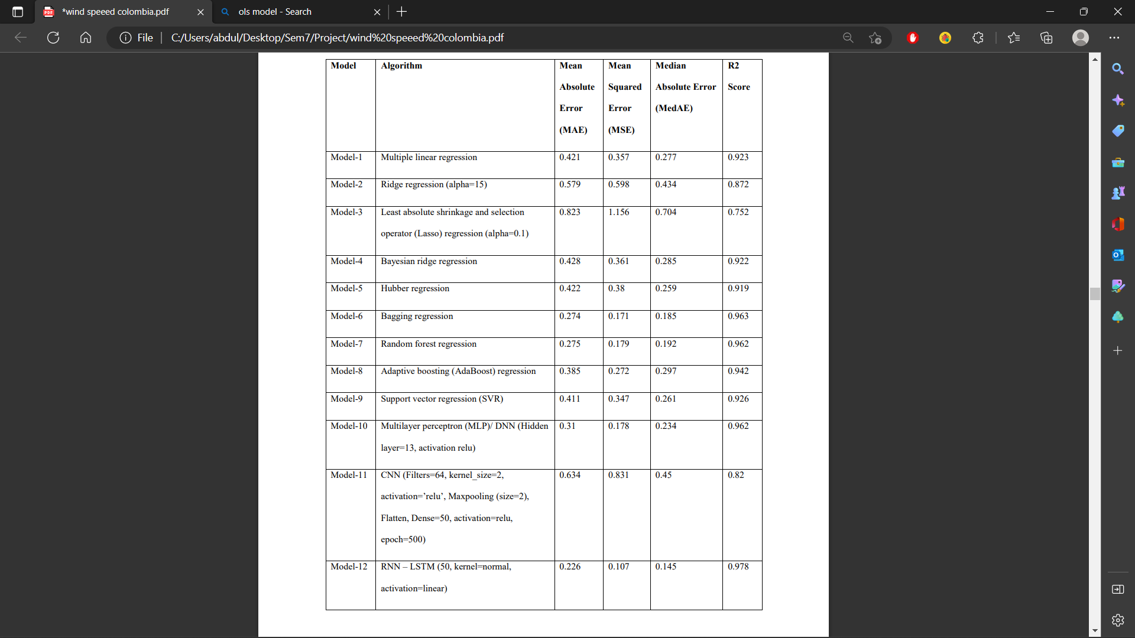

Table 1 Comparative Model Performances

**RESEARCH PAPER 2**

Title: A Review of QR code Structure for Encryption and Decryption Process

Author: Divya Sharma

Publishers: International Journal of Innovative Science and Research Technology

ISSN No: - 2456- 2165

Key-points:

QR Code is a matrix or a 2-dimensional barcode based symbol with a cell structure which is formatted in a square.

It can store up to 4296 alphanumeric characters and can be read by optical device with the appropriate software like QR code reader and mobile phones.

QR code structure:

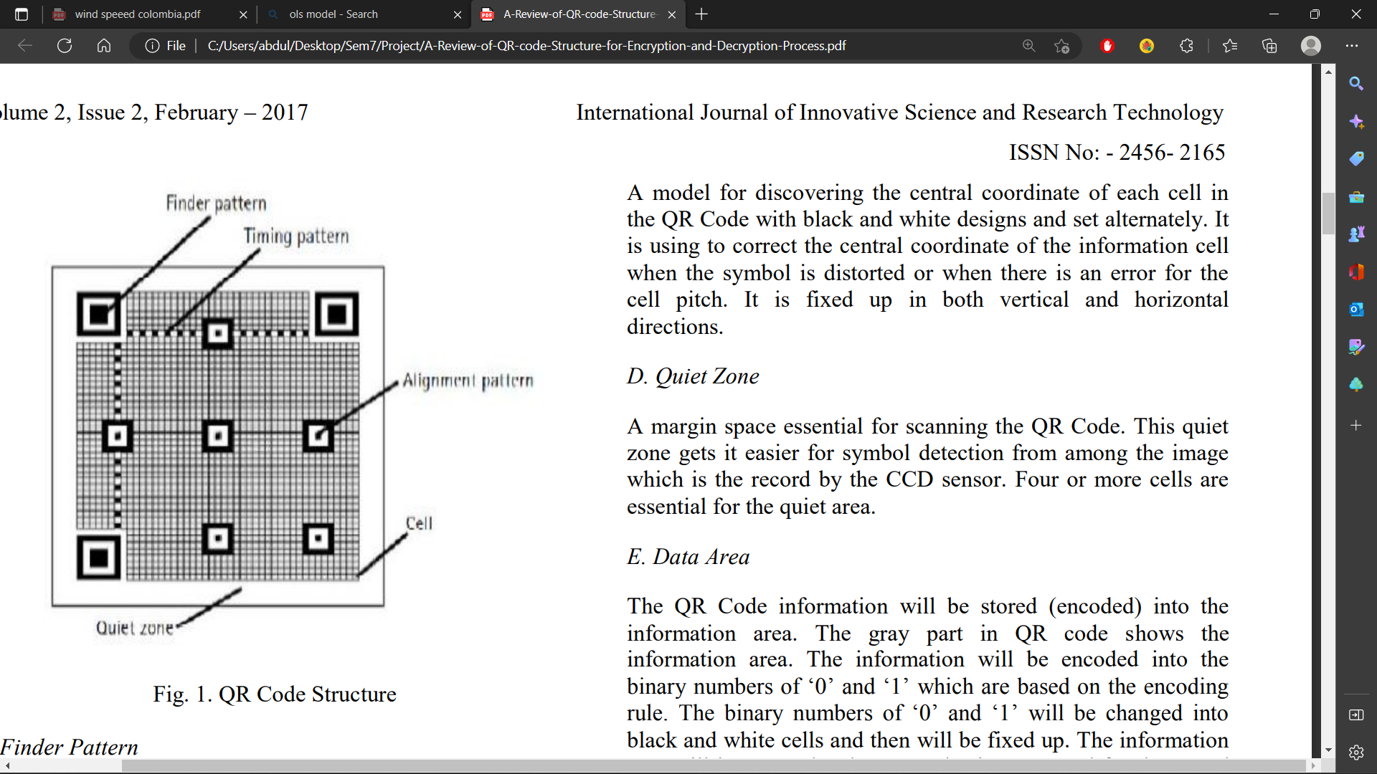

1. **Finder Pattern**

Finder Patterns are separated from the rest of a QR Code by a light area of width one module. Finder Patterns are used by readers to determine position and orientation of a QR Code. The finder pattern consists of three identical structures that are located in all corners of the QR Code except the bottom right corner. Each pattern is based on a 3x3 matrix of black modules surrounded by white modules that are again surrounded by black modules. The Finder Patterns enable the decoder software to recognize the QR Code and determine the correct orientation.

1. **Alignment Pattern**

There may be none or more alignment patterns according to a version of a QR Code (QR Code version 1 has no alignment pattern). They allow the scanning device to determine the possible perspective distortion of the QR Code image. Alignment Patterns support the decoder software in compensating for moderate image distortions. Version 1 QR Codes do not have Alignment Patterns. With growing size of the code, more Alignment Patterns are added.

1. **Timing Pattern**

Alternating black and white modules in the Timing Pattern enable the decoder software to determine the width of a single module. These are placed inside a QR Code and interconnect finder patterns. Timing patterns are formed by sequence of alternating dark and light modules. The timing pattern is used to determine the size of a module, the number of rows and columns, and possible distortion of a code.

1. **Quite Zone**

Quiet zone is the blank margin on the either side of a barcode that's used to tell the barcode scanner where a barcode's symbol starts and stops. The purpose of a Quiet Zone is to prevent the scanner from picking up information that does not pertain to the barcode scanned. This is a white area of width at least four modules located around a QR Code (in practice, the width is often less than four modules as required by the standard). The quiet zone should not contain any patterns or structures which can confuse readers.

1. **Data Area**

Data is converted into a bit stream and then stored in 8 bit parts (called code words) in the data section. They are encoded inside a QR Code and are protected by an error correction carried out via a Reed–Solomon algorithm (allows restoration of damaged data). This also means that a QR Code can be partially damaged and can still be entirely read out. QR Codes provide four user selectable levels of error correction: L (Low), M (Medium), Q (Quartile), and H (High). It means that up to approximately 7%, 15%, 25%, and 30% of the code words, which are damaged, can be restored [3]. Increasing the level of error correction reduces the available data capacity of a QR Code.

**CHAPTER 3:**

**3. PROPOSED APPROACHES**

**3.1 APPROACHES TO PROJECT**

We Started by finding the need of an inventory management system in an organization. Basically finding out reasons why we need an interactive, automated inventory management system. We visited a wide number of websites, and also talked with organizations so as to gain some knowledge about their past experience regarding management of stock.

Before developing this application we came up with 2 Inventory Management System existing in the market, which helps to give the knowledge for the development of our project. These application software are only used by the large organization but so we came up with the application which can be used by the small company for the management of their stock in the production houses. After analyzing the other inventory management system we decided to include some of common and key features that should be included in every inventory management system. So we decided to include those things that help the small organization in a way or other.

We used various techniques to collect information regarding need of inventory management system like we talked with developers, visited websites which involve management of inventory and got to know that the various factors which forced us to develop inventory management system are:

* Lack of stock management.
* Difficulty in monitoring the stock.
* Effective flow of stock information within organization.
* Real-time updates regarding stock.
* Increasing business profits.
* Prevent the problems caused by overstock.

**3.2 PROPOSED SOLUTIONS/ ALGORITHMS**

The proposed solution of the project is an Inventory Management System, which is a comprehensive mobile and web-based application developed using Flutter technology and Android Studio software. The system uses Nodejs, Expressjs for designing the backend to provide a comprehensive overview of the organization's stock and for efficient and effective management of inventory.

The key features of the system include real-time inventory updates, which will provide accurate information on the remaining balance of stock and transaction details. The system also includes a feature for tracking operator activities, which will store information about all operations that modify the database records, such as adding, updating, and deleting inventory items. This feature will provide an auditing system for the organization and ensure transparency and accountability.

The system also includes a QR code system, which will allow for quick and efficient retrieval of information about the items and quantities in a box. The QR code will be generated after the operator adds the item details and can be printed and attached to the box. Once scanned, the item details will be displayed in the system, allowing the operator to make modifications as needed.

In addition, the system includes a secure database that can only be accessed by the administrator. This will protect the management of the organization's stock and prevent unauthorized access. The login page ensures that only authorized personnel can access the system.

In conclusion, the Inventory Management System is designed to provide a comprehensive overview of the organization's stock, allow for efficient and effective management of inventory, and ensure transparency and accountability. The use of Flutter, Android Studio, Nodejs, and Expressjs technologies in designing and implementing the system will provide a user-friendly and efficient solution for Anemos Energies Goa.

The proposed solution of the project includes an intelligent technique for forecasting wind speed and power output of a wind turbine for the next whole month on a daily basis. The forecasting system will help customers plan power usage and make informed decisions about the purchase of wind turbines for their location. The system will utilize publicly available weather and energy data sets to generate the forecasts. It will consider various features, such as temperature, wind direction, and atmospheric pressure, to improve the accuracy of the forecasts. This system will be integrated into the inventory management system for Anemos Energies Goa to improve the overall efficiency and effectiveness of wind energy generation.

Algorithms:

Tracking operator activities:

1. Initialize the system with the list of possible operator activities (e.g. adding, updating, and deleting inventory items).
2. When an operator performs an action, log the action with the following details: date, time, type of action, item(s) affected, and operator's name/identifier.
3. Store the log in a secure database that can only be accessed by the administrator.
4. When the administrator needs to view the operator activities, retrieve the log from the database and present it to the administrator.
5. The administrator can then use the log to accurately identify the operator responsible for any errors or inaccuracies in the inventory records and make necessary corrections.

Generating QR code:

1. Start the application and navigate to the QR code generation screen.
2. Enter the item details such as name, quantity, and date into the form.
3. The application will generate a QR code based on the entered information.
4. The QR code is displayed on the screen and can be saved or printed.
5. The QR code is attached to the item's box or packaging.
6. The QR code can be scanned later to retrieve the item details for updating or viewing.

Scanning QR code:

1. Start the application and navigate to the QR code scanning screen.
2. Point the device camera at the QR code.
3. The application will detect the QR code and capture its image.
4. The image is processed to extract the data encoded in the QR code.
5. The extracted data is compared against the database to retrieve information about the item.
6. If a match is found, the item details are displayed on the screen for the operator to view.
7. The operator can modify the details as required and update the database.

Generating forecasting model:

1. Load the publicly available weather and energy data sets into the system.
2. Pre-process the data to remove any missing values, outliers, and noise.
3. Select relevant features to be used for the model, such as temperature, wind direction, and atmospheric pressure.
4. Use RNN-LSTM (Recursive Neural Network Long Short-term Memory) machine learning algorithms.
5. Train the model on a portion of the data and validate its performance on the remaining data.
6. Evaluate the model's performance using metrics such as mean squared error and R-squared.
7. If the performance is not satisfactory, repeat steps 4 to 6 with different algorithms or features.
8. Finally, use the generated model to forecast wind speed and power output for the next month on a daily basis.
9. Store the forecasted values in the database for future reference and comparison.

**CHAPTER 4**

1. **REQUIREMENT SPECIFICATIONS**

**4.1 SOFTWARE REQUIREMENTS:**

**Windows**:

* **Microsoft® Windows® 7/8/10 (64-bit)**
* **Android studio.**

Android Studio is the official integrated development environment (IDE) for Google's Android operating system, built on JetBrains' IntelliJ IDEA software and designed specifically for Android development. It is available for download on Windows, macOS and Linux based operating systems. It is a replacement for the Eclipse Android Development Tools (E-ADT) as the primary IDE for native Android application development.

* **Visual studio code**

Visual Studio Code, also commonly referred to as VS Code, is a source-code editor made by Microsoft with the Electron Framework, for Windows, Linux and macOS. Features include support for debugging, syntax highlighting, intelligent code completion, snippets, code refactoring, and embedded Git. Users can change the theme, keyboard shortcuts, preferences, and install extensions that add additional functionality.

* **SQL**

SQL stands for Structured Query Language. SQL lets you access and manipulate databases. SQL became a standard of the American National Standards Institute (ANSI) in 1986, and of the International Organization for Standardization (ISO) in 1987.

* **Xampp**

XAMPP is a free and open-source cross-platform web server solution stack package developed by Apache Friends,consisting mainly of the Apache HTTP Server, MariaDB database, and interpreters for scripts written in the PHP and Perl programming languages. Since most actual web server deployments use the same components as XAMPP, it makes transitioning from a local test server to a live server possible.

**4.2 HARDWARE REQUIREMENTS:**

* 4 GB RAM minimum, 8 GB RAM recommended
* 2 GB of available disk space minimum,
* 4 GB Recommended (500 MB for IDE + 1.5 GB for Android SDK and emulator system image)
* 1280 x 800 minimum screen resolution

**Mac**:

* Mac® OS X® 10.10 (Yosemite) or higher, up to 10.14 (macOS Mojave)
* 4 GB RAM minimum, 8 GB RAM recommended
* 2 GB of available disk space minimum,
* 4 GB Recommended (500 MB for IDE + 1.5 GB for Android SDK and emulator system image)
* 1280 x 800 minimum screen resolution

**Linux**:

* GNOME or KDE desktop - *Tested on gLinux based on Debian*.
* 64-bit distribution capable of running 32-bit applications
* GNU C Library (glibc) 2.19 or later
* 4 GB RAM minimum, 8 GB RAM recommended
* 2 GB of available disk space minimum,
* 4 GB Recommended (500 MB for IDE + 1.5 GB for Android SDK and emulator system image)
* 1280 x 800 minimum screen resolution

**Chrome OS**:

* 8 GB RAM or more recommended
* 4 GB of available disk space minimum
* 1280 x 800 minimum screen resolution
* Intel i5 or higher (U series or higher) recommended

**CHAPTER 5**

1. **DESIGN:**

**5.1 DATA FLOW DIAGRAM :**

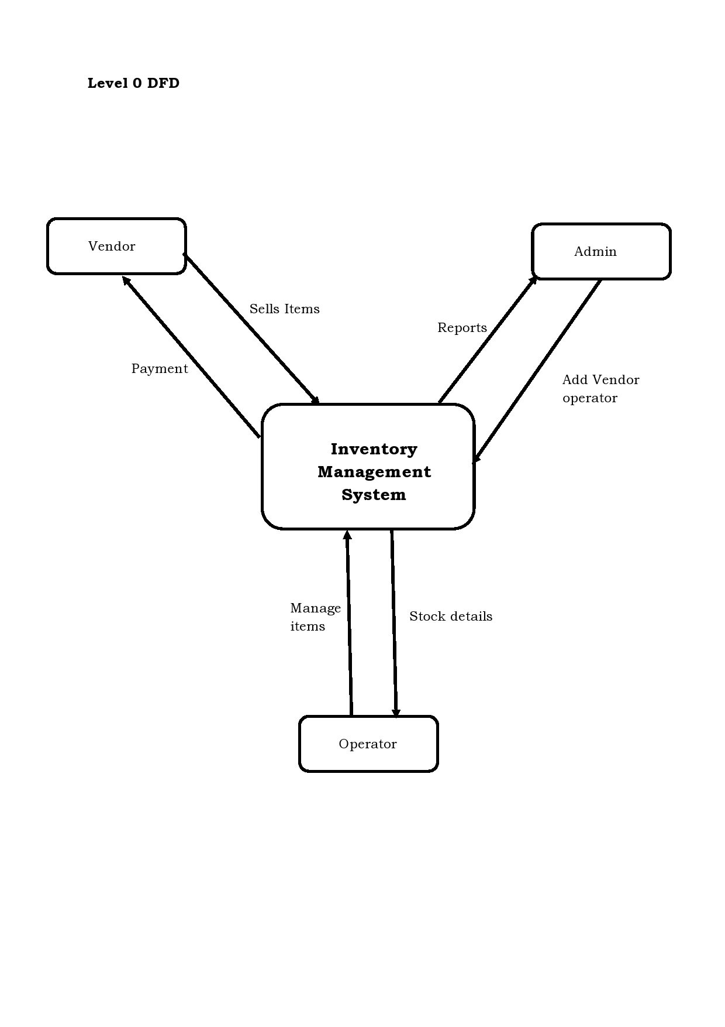

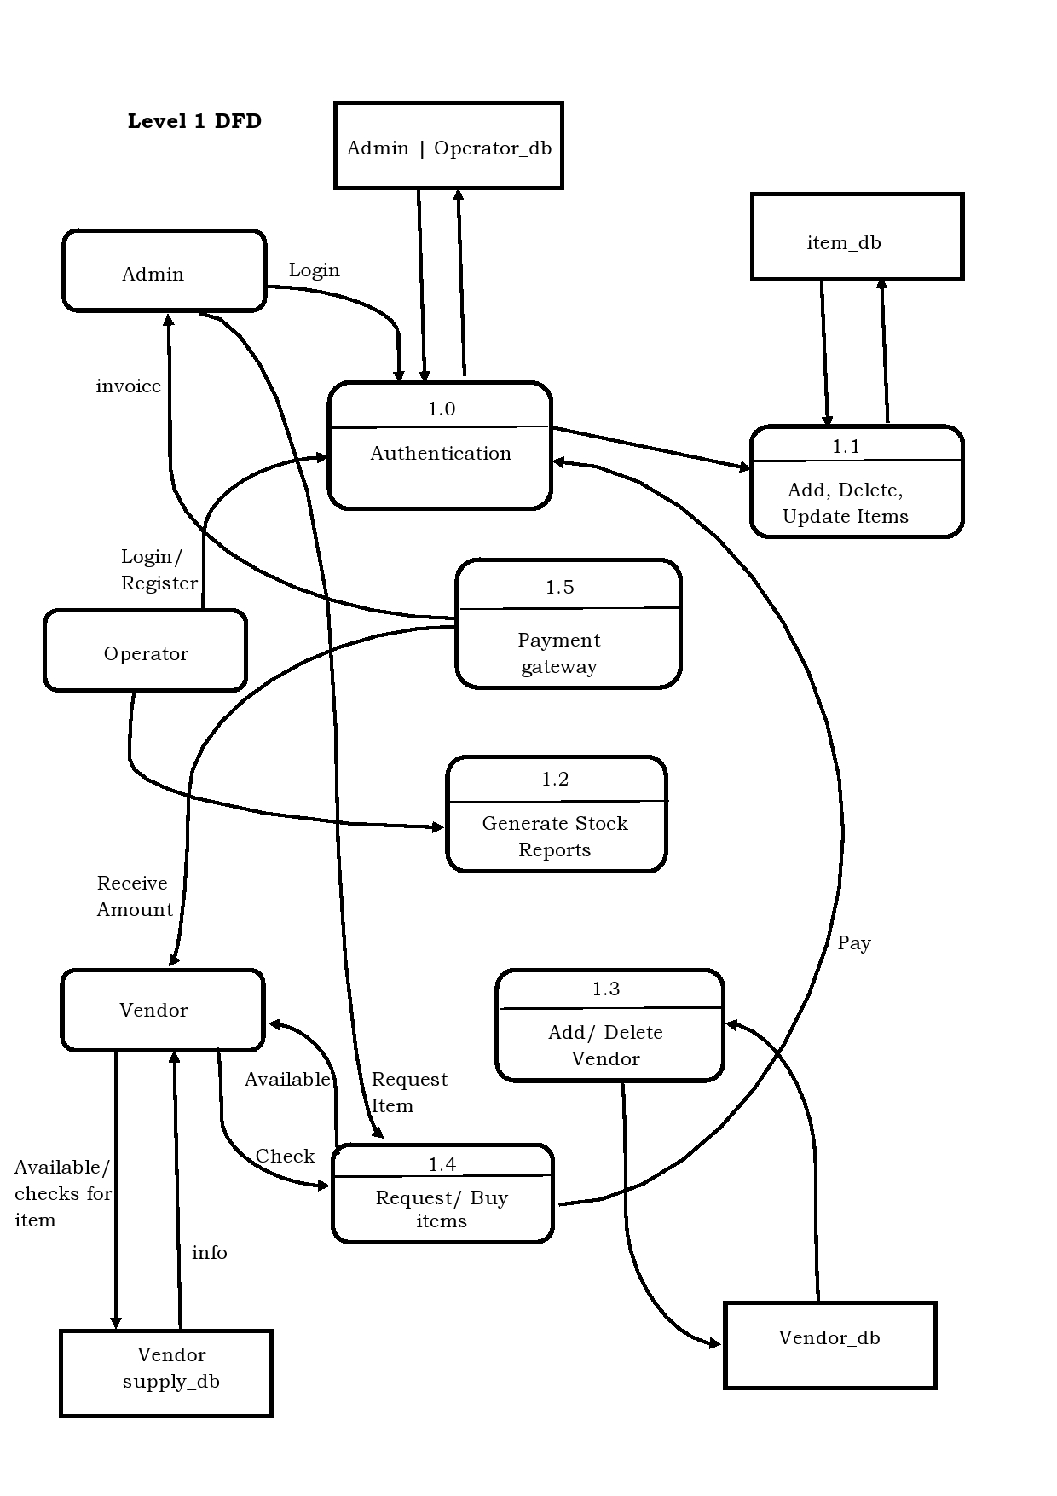

* 1. **DETAIL FLOW OF ARCHITECTURE**

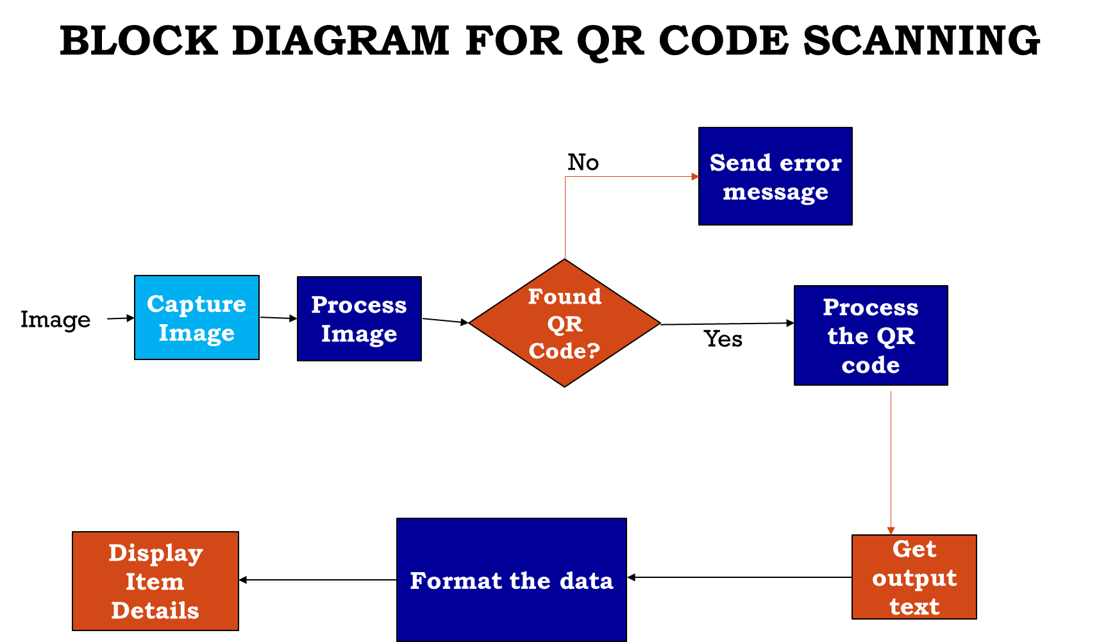

**Block diagram of QR code scanning**

**Flow architecture of wind prediction steps**

**CHAPTER 6**

1. **DATASETS/ SIMULATION**

**6.1 DETAILS ABOUT DATABASE TO BE USED**

The dataset for wind prediction system was taken from <https://power.larc.nasa.gov/data-access-viewer/> website. It has hourly weather data starting from 2001 till date. The user can easily specify the location coordinates of place whose data he needs and has to specify the attributes required.

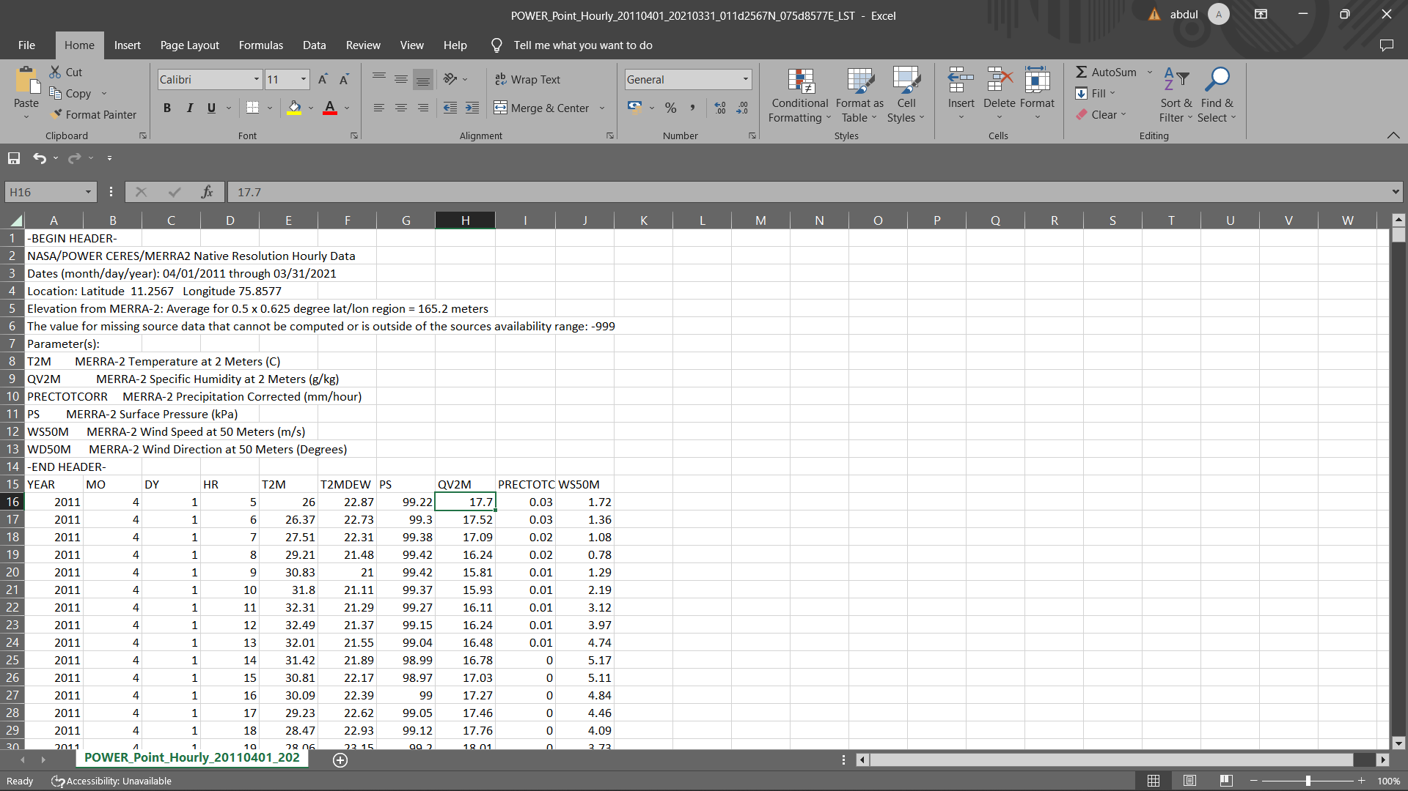

* 1. **Work Done / Testing On The Dataset**

**CHAPTER 7**

1. **Implementation**

**UI:**

Admin Console.

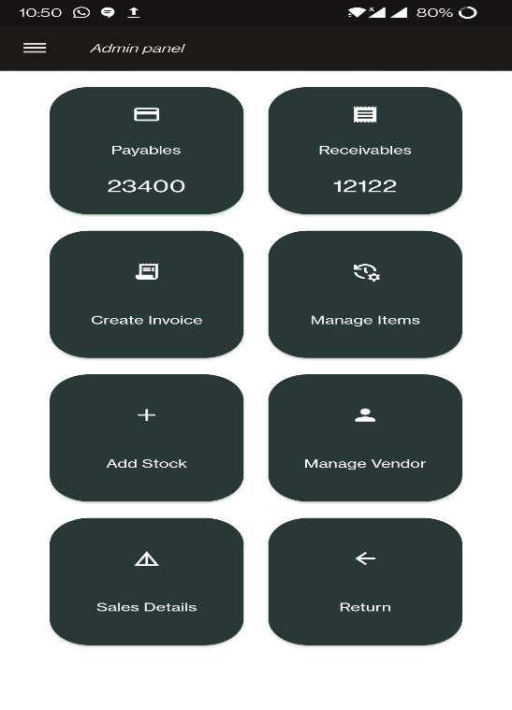

Add Stock Screen

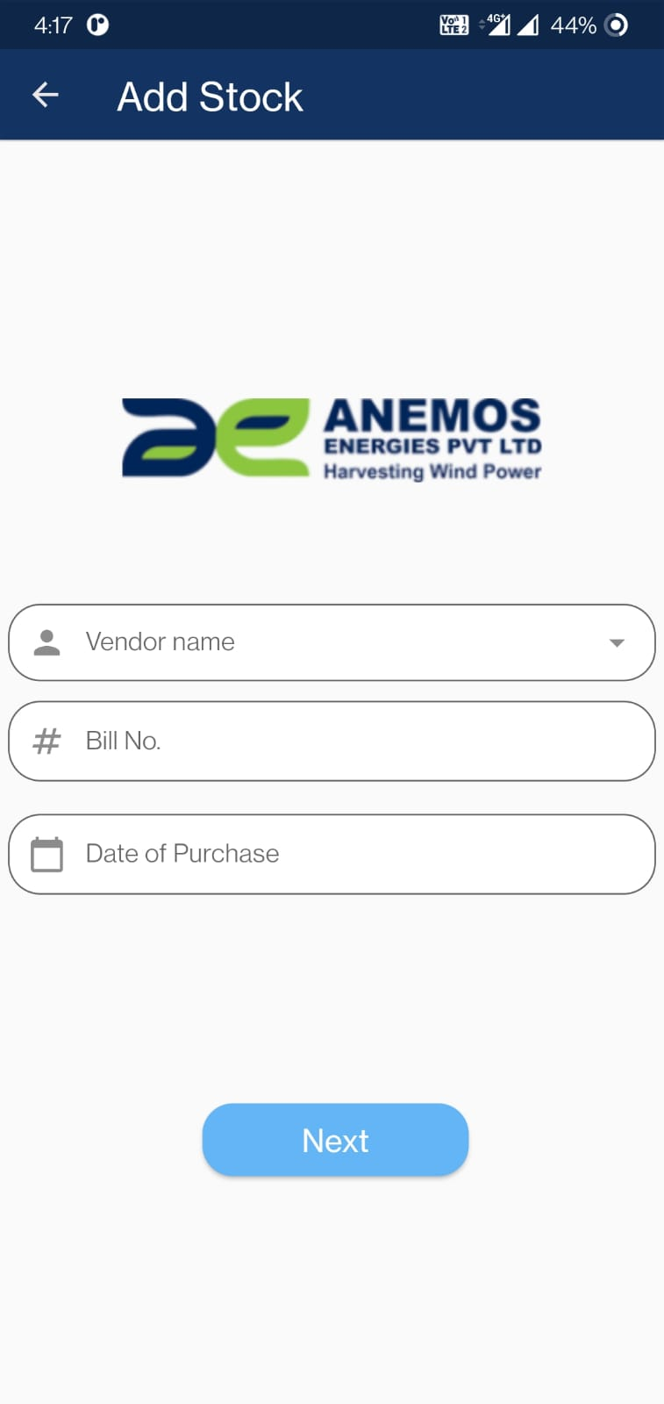 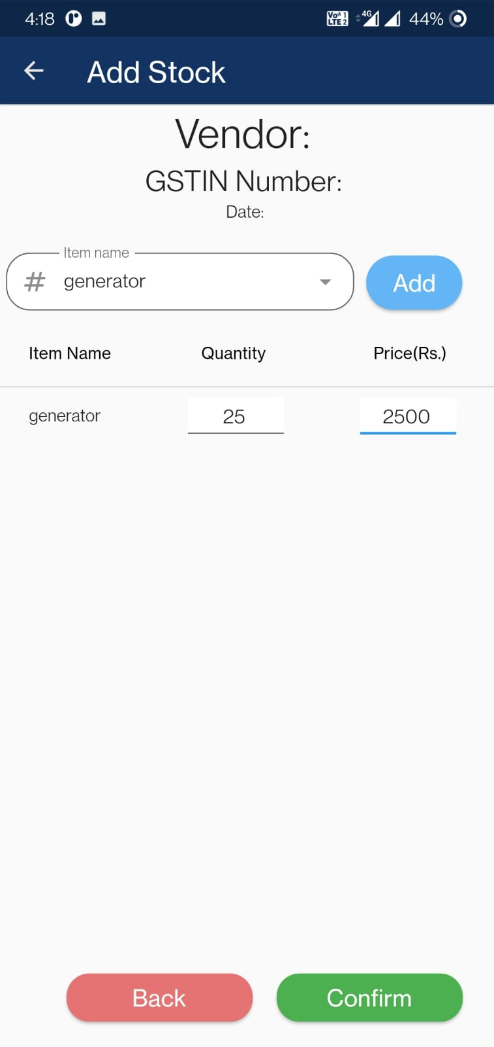

Add Item Screen:

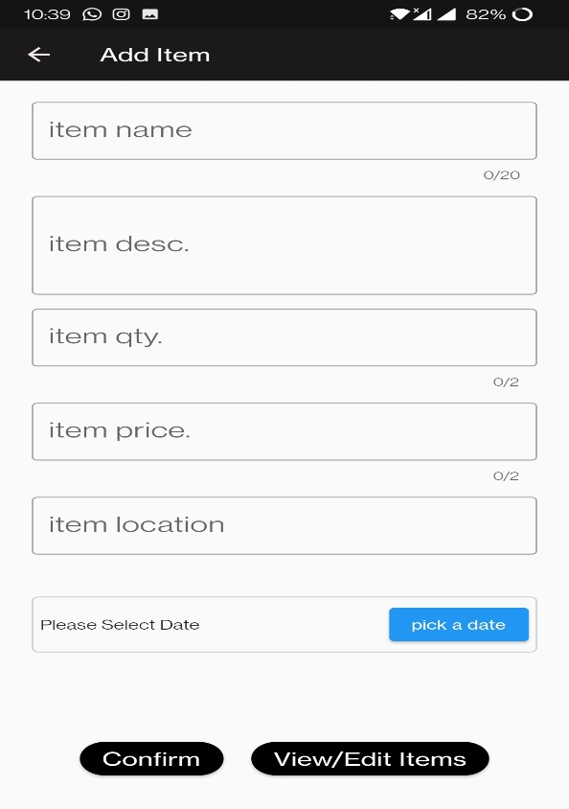

Login Screen:

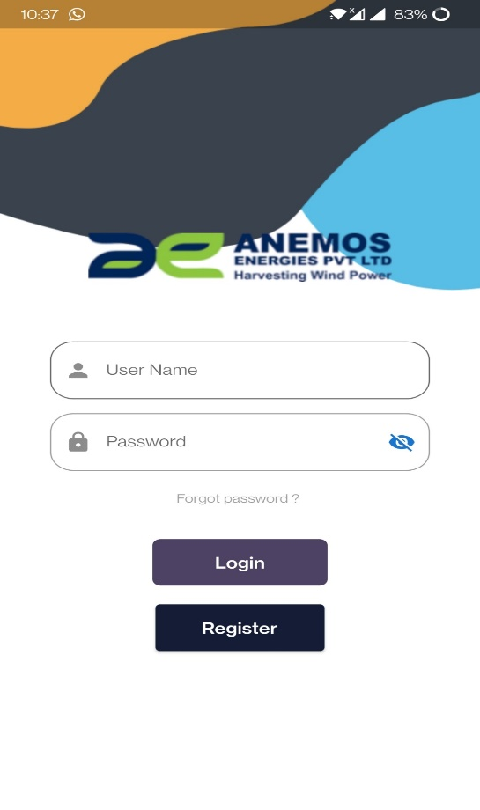

**CHAPTER 8**

1. **Conclusion**

The Inventory Management System and wind forecasting solution for Anemos Energies Goa is a comprehensive and innovative solution that addresses the challenges faced by the organization in managing and optimizing their inventory and wind energy generation. The solution utilizes cutting-edge technologies such as Flutter, Android Studio, Nodejs, and Expressjs, and features real-time inventory updates, operator activity tracking, QR code system, and secure database. The wind forecasting system leverages publicly available weather and energy data sets and employs intelligent techniques to provide accurate and reliable monthly predictions of wind speed and power output. The proposed solution offers a unified and user-friendly interface that streamlines the process of managing inventory and optimizing wind energy generation. The successful implementation of this project will bring significant benefits to Anemos Energies Goa, including increased efficiency, transparency, and accountability, and a better understanding of their inventory and energy generation.

**CHAPTER 9**

1. **BIBLIOGRAPHY**

Android Studio. (2021). Android Studio. [online] Available at: https://developer.android.com/studio [Accessed 2021].

Flutter. (2021). Flutter. [online] Available at: https://flutter.dev/ [Accessed 2021].

Node.js. (2021). Node.js. [online] Available at: https://nodejs.org/ [Accessed 2021].

Express. (2021). Express. [online] Available at: https://expressjs.com/ [Accessed 2021].

Anemos Energies Goa. (2021). Anemos Energies Goa. [online] Available at: https://www.anemosenergies.com/goa [Accessed 2021].

Wind Energy Generation. (2021). Wind Energy Generation. [online] Available at: https://en.wikipedia.org/wiki/Wind_energy_generation [Accessed 2021].

Weather Data Sets. (2021). Weather Data Sets. [online] Available at: https://www.ncdc.noaa.gov/cdo-web/datasets [Accessed 2021].